Q1.
Lactose is the main sugar in milk and is hydrolysed by the enzyme lactase. Lactase is essential to newborn mammals as milk is their only source of food. Most mammals stop producing lactase when they start feeding on other food sources. Humans are an exception to this because some continue to produce lactase as adults. The ability to continue producing lactase is known as lactase persistence (LP) and is controlled by a dominant allele. A number of hypotheses based on different selection pressures have been put forward to explain LP in humans.
(a) One hypothesis for LP in humans suggests that the selective pressure was related to some human populations farming cattle as a source of milk.
Describe how farming cattle as a source of milk could have led to an increase in LP.
Individuals with LP more likely to survive and reproduce and also individuals with advantageous allele are more likely to survive and reproduce, this is through, directional selection, whereby the frequency of allele increases in offspring in the next generation
(4)
(b) Use the information provided to explain why the number of people showing LP would rapidly increase once selection for this condition had been established.
This will be because of the dominant allele which is always expressed or shown when present in phenotype of the offspring or Expressed when only one dominant allele present
(2)
(c) Lactase persistence is caused by a mutation in DNA. This mutation does not occur in the gene coding for lactase.
Suggest and explain how this mutation causes LP.
Mutation in promoter DNA or gene for transcription factor therefore, lactase gene continues to be transcribed or being active
(2)
(Total 8 marks)
Q2.
(a) What is a gene pool?
Gene pool is the total genetic diversity found within a population or a species
(1)
(b) Lord Howe Island in the Tasman Sea possesses two species of palm tree which have arisen via sympatric speciation. The two species diverged from each other after the island was formed 6.5 million years ago. The flowering times of the two species are different.
Using this information, suggest how these two species of palm tree arose by sympatric speciation.
As a result of sympatric speciation, the two species occurs in the same environment, mutations then cause different flowing times resulting to reproductive separation. The offspring then pass on different alleles leading to disruptive selection, and eventually different species cannot interbreed to produce fertile offspring
(5)
(Total 6 marks)
Q3.
To reduce the damage caused by insect pests, some farmers spray their fields of crop plants with pesticide. Many of these pesticides have been shown to cause environmental damage.
Bt plants have been genetically modified to produce a toxin that kills insect pests. The use of Bt crop plants has led to a reduction in the use of pesticides.
Scientists have found that some species of insect pest have become resistant to the toxin produced by the Bt crop plants.
The figure below shows information about the use of Bt crops and the number of species of insect pest resistant to the Bt toxin in one country.
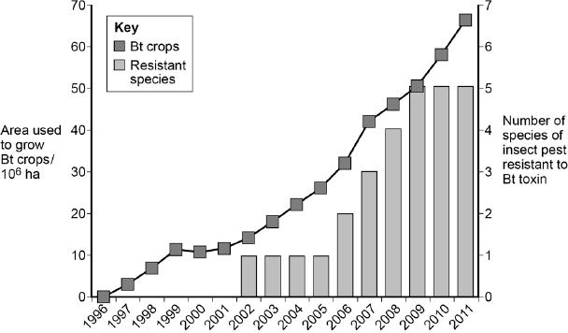
Year
(a) Can you conclude that the insect pest resistant to Bt toxin found in the years 2002 to 2005 was the same insect species? Explain your answer.
The bar chart only shows number of species, not the name of the species
(1)
(b) One farmer stated that the increase in the use of Bt crop plants had caused a mutation in one of the insect species and that this mutation had spread to other species of insect. Was he correct? Explain your answer.
No the farmer was not correct. Mutations are spontaneous and only the rate of mutation is affected by environment. Therefore different species do not interbreed to produce fertile offspring. So mutation cannot be passed from one species to another
(4)
(c) There was a time lag between the introduction of Bt crops and the appearance of the first insect species that was resistant to the Bt toxin.
Explain why there was a time lag.
Initially only a few insects with favourable mutation or allele were present. Individuals with the favourable allele will have more offspring but it takes many generations for the favourable allele to become the most common allele of this gene thus the time lag
(Total 8 marks)
Q4.
Malaria is a disease that is spread by insects called mosquitoes. In Africa, DDT is a pesticide used to kill mosquitoes, to try to control the spread of malaria.
Mosquitoes have a gene called KDR. Today, some mosquitoes have an allele of this gene, KDR minus, that gives them resistance to DDT. The other allele, KDR plus, does not give resistance.
Scientists investigated the frequency of the KDR minus allele in a population of mosquitoes in an African country over a period of 10 years.
The figure below shows the scientists’ results.
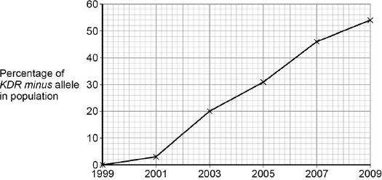
Year
(a) Use the Hardy–Weinberg equation to calculate the frequency of mosquitoes heterozygous for the KDR gene in this population in 2003.
Show your working.

P^2 =0.4
p=0.2
q=1-0.2
q= 0.8
2pq=2x (0.2x0.8)
2pq=0.32
=32%

Frequency of heterozygotes in population in 2003 ____0.32 or 32%________________
(2)
(b) Suggest an explanation for the results in the figure above.
KDR minus gene, more advantageous so more likely to survive and reproduce, increase frequency in gene pool. Those without mutation die
(4)
The KDR plus allele codes for the sodium ion channels found in neurones.
(c) When DDT binds to a sodium ion channel, the channel remains open all the time.
Use this information to suggest how DDT kills insects.
When DDT binds to a sodium ion channel, the channel remains open all the time, neurones remain polarised, resulting to no action potentials killing the insects.
(2)
(d) Suggest how the KDR minus allele gives resistance to DDT.
It changes the shape of sodium ion channel, DDT no longer become complementary
(2)
(Total 10 marks)
Q5.
There are wolves in many European countries. Scientists investigated the genetic diversity of these wolves. They collected samples of DNA from the mitochondria of wolves from different countries. For each sample they identified which haplotypes were present in the DNA. A haplotype is a particular sequence of bases on DNA. Mutations can produce new haplotypes.

Country | Number of wolves  sampled | Number of different  haplotypes in  mitochondrial DNA
Spain | 84 | 3
Portugal | 19 | 2
Italy | 101 | 1
France | 7 | 1
Bulgaria | 29 | 6
Sweden | 93 | 1
The scientists wanted to find out whether one of the haplotypes in the Portuguese wolves was the same as one of those in the Spanish wolves. They used a restriction endonuclease, electrophoresis and a labelled DNA probe.
(a) For what purpose did they use
(i) the restriction endonuclease
It was used to cut the DNA.
(1)
(ii) electrophoresis?
Electrophoresis was used to separate the pieces of DNA
(1)
(b) Explain why the labelled DNA probe could be used to find out whether the haplotypes were the same.
Complimentary base sequence or complementary DNA binds to both haplotypes showing up the Label both
(2)
(c) The scientists analysed the DNA on the Y chromosome and the DNA in the mitochondria of the Swedish wolves. They concluded that the Swedish wolf population descended from one male wolf from Finland and one female wolf from Russia.
(i) Explain why DNA on the Y chromosome helped them to reach this conclusion.
Y chromosome is only inherited from male parents
(1)
(ii) Suggest why DNA in the mitochondria helped them to reach this conclusion.
Mitochondria in the female gamete and no mitochondria come from male gamete
(1)
Wolves eat different mammals. An ecologist investigated factors that affect wolf numbers in North America. He collected data from different field studies carried out in different places. The graph shows his results.
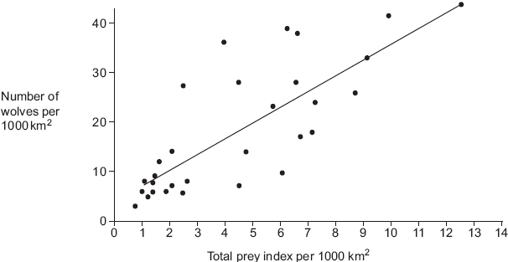
(d) (i) The wolf numbers are given per unit area. Explain why.
Allows comparison between the Different areas covered
(2)
(ii) The ecologist calculated the total prey index for each of the places that had been studied. In order to do this, he gave each prey species a value based on how much food was available to wolves from the prey animal concerned. He called this value the prey index.
The ecologist considered that the prey index gave a better idea of the food available than the prey biomass in kg. Suggest why the prey index gives a better idea of food available.
Wolves do not eat all of prey animal therefore the inedible parts make up different proportions
(2)
(e) The ecologist calculated the total prey index by combining the prey indices and the total number of animals of each species present in 1000 km². He plotted this information on the graph. What does the graph suggest about the factors that determine wolf numbers in North America? Explain your answer.
Since the wolves are limited by food, as prey increases so do wolf numbers giving a positive correlation;
(Total 12 marks)
Q6.
Ecologists studied a community of fish in a lake.
(a) Explain what is meant by a community.
A community is all the fish or organisms in the lake
could have used the mark-release-recapture method to estimate the number of one species of fish in the lake. Describe how.
__The first step is to capture a sample, mark and release this entails use of the appropriate method of marking that does not harm fish;
The second step is to capture a second sample and count marked organisms;
Population = sample1 × sample2 divided by the number marked in sample2

(3)
(ii) This species of fish breeds at a certain time of the year. During this fish-breeding season, the mark-release-recapture technique might not give a reliable estimate.
Suggest one reason why.
As the fish breed, the population increases leading to changes between first and second sample
(1)
(c) The ecologists found that each species of fish had adaptations to its niche. One of these adaptations was the shape of its mouth.
Suggest how the shape of mouth is an adaptation to its niche.
_ Different fish species with different shapes of the mouth eats different food thus interspecific competition is reduced.
(2)
(Total 7 marks)
Q7.
There are nine subspecies of giraffe. These subspecies evolved when populations of giraffe were separated for long time periods. Each subspecies has distinct coloured skin markings. Some biologists have suggested that up to six of these subspecies should be classified as different species.
(a) Explain how different subspecies of giraffe may have evolved from a common ancestor.
Use information from the passage in your answer.
Since the giraffes were separated, there was no interbreeding. The Mutation is thus linked to different markings of colours. Selection of the species is thus linked to the different markings of colours. The adapted giraffes breed leading to increase in allele frequencies
(5)
(b) Biologists compared the mitochondrial DNA of the different subspecies of giraffe. They used the results from comparing this DNA to conclude that six of the nine subspecies are separate species.
Suggest how they came to this conclusion.
Comparing DNA base sequence revealed that the sequence is different in six subspecies but similar in three subspecies
(Total 7 marks)
Q8.
Malaria is a disease that destroys red blood cells. Scientists investigated whether certain red blood cell phenotypes were associated with developing severe or mild malaria. They compared the red blood cell phenotypes of hospital patients suffering from severe malaria with the red blood cell phenotypes of patients suffering from mild malaria. The results are shown in the table.

Red blood cell phenotype | Ratio of patients with  severe malaria : patients  with mild malaria
Sickle cell trait | 0.48 : 1
Blood group A | 2.45 : 1
Blood group O | 0.96 : 1
(a) Explain the advantage of presenting the results as a ratio.
Using ratios allows valid comparison
(2)
(b) What do these data show about the effect of red blood cell phenotypes on the chance of developing severe malaria rather than mild malaria?
Increased chance of severe malaria with blood group A. A decreased chance of severe malaria with sickle cell and an almost equal chance with blood group O
(2)
(c) The allele for normal haemoglobin in red blood cells is Hb^{A}. In some parts of Africa where malaria occurs there is a high frequency in the population of the allele Hb^{C}.
Individuals possessing the Hb^{C} allele have a lower chance of developing severe malaria. Severe malaria causes a large number of deaths in Africa.
Explain the high frequency of the Hb^{C} allele in areas where malaria occurs.
Individuals with the HbC allele reproduce and Pass on HbC allele which increases in frequency. HbA individuals are less likely to reproduce thus the frequency of HbA allele decreases
(3)
(Total 7 marks)
Q9.
Schizophrenia is a mental illness. Doctors investigated the relative effects of genetic and environmental factors on the development of schizophrenia. They used sets of identical twins and non-identical twins in their investigation. At least one twin in each set had developed schizophrenia.
• Identical twins are genetically identical.
• Non-identical twins are not genetically identical.
• The members of each twin pair were raised together.
The table shows the percentage of cases where both twins had developed schizophrenia.

Type of twin | Percentage of cases where both twins had developed schizophrenia
Identical | 50
Non-identical | 15
(i) Explain why both types of twin were used in this investigation.
Identical twins show genetic influence and differences between them show environmental influence. Non-identical twins also show an environmental/non-genetic influence;
(2)
(ii) What do these data suggest about the relative effects of genetic and environmental factors on the development of schizophrenia?
The data shows that generic factors contribute to the development of schizophrenia than do environmental factors.
(1)
(iii) Suggest two factors that the scientists should have taken into account when selecting the twins to be used in this study.
1. __Environment they are raised in _______________________________________________________________
2. __Genetic composition ____________________________________________________________
(2)
(Total 5 marks)
Q10.
(a) Energy enters most ecosystems through the light-dependent reaction of photosynthesis. Describe what happens during the light-dependent reaction.
In the light-dependent reactions, which take place at the thylakoid membrane, chlorophyll absorbs energy from sunlight and then converts it into chemical energy with the use of water. The light-dependent reactions release oxygen as a by-product as water is broken apart.
(5)
(b) Changes in ecosystems can lead to speciation. A high concentration of copper in soil is toxic to most plants. In some areas where the soil is polluted with copper, populations of grasses are found to be growing. These populations of grass belong to a species also found growing on unpolluted soils.
It has been suggested that a new species of grass may evolve on soil that has been polluted with copper. Explain how this new species might evolve.
Due to mutation adapted organisms reproduce in differential reproductive success
(5)
(Total 10 marks)

